1.SIMPLE INTEREST

<!DOCTYPE html>

<html>

<head>

<title>SIMPLE INTEREST</title>

</head>

<body>

<h1>SIMPLE INTEREST</h1>

<script type="text/javascript">

function interest(p ,n ,r)

{

res=(p*n*r)/100;

console.log("principle: "+p,"number of years: ",n,"rate of interest: ",r)

return res;

}

result=interest(1000,1/2,4);

console.log("result of simple interest ",result)

</script>

</body>

</html>

**OUTPUT**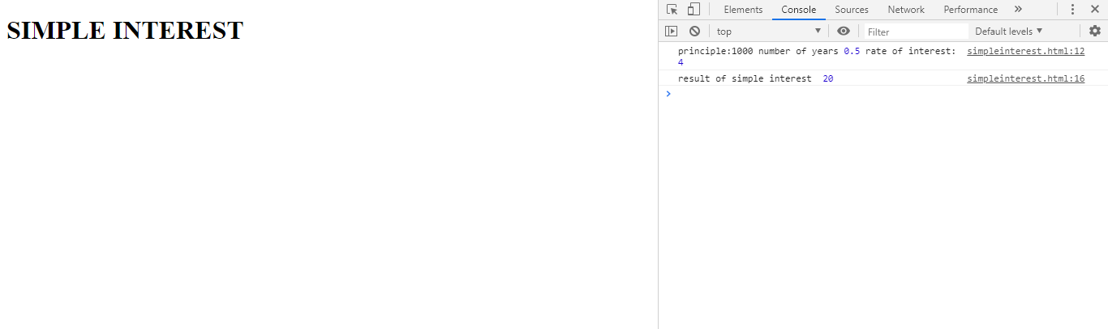

2.ODD/EVEN

<!DOCTYPE html>

<html>

<head>

<title>ODD/EVEN</title>

</head>

<body>

<h1>ODD/EVEN</h1>

<script type="text/javascript">

function oddeven(n)

{

if(n%2==0){

console.log("even no:"+n);

}else{

console.log("odd no" +n);

}}

result=oddeven(42);

</script>

</body>

</html>

**OUTPUT**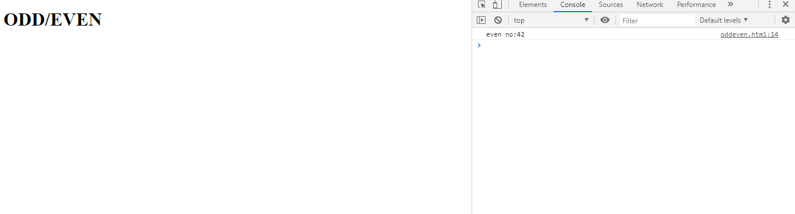

3.PRIME NUMBER

<!DOCTYPE html>

<html>

<head>

<title>PRIME NO</title>

</head>

<body>

<h1>PRIME NUMBER</h1>

<script type="text/javascript">

function prime(n)

{

count=0;

for(i=1;i<=n;i++)

{

if(n%i==0)

{

count=count+1;

}

}

if(count==2)

{

console.log("prime :"+n)

}

else

{

console.log("not prime:"+n)

}

}

result=prime(8);

</script>

</body>

</html>

**OUTPUT**

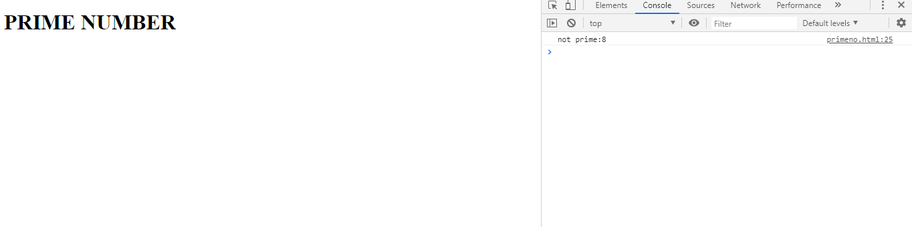

4: Celsius to Fahrenheit and vice versa

<!DOCTYPE html>

<html>

<head>

<title>CELSIUS TO FAHRENHEIT</title>

</head>

<body>

<h1>CELSIUS TO FAHRENHEIT</h1>

<script type="text/javascript">

function celsiusFahrenheit(celsius)

{

res=(celsius*9/5)+32;

console.log(celsius,"celsius to fahrenheit is" +res +"F");

}

function Fahrenheit(fahren)

{

res=(fahren-32)*5/9

console.log(fahren,"fahrenheit to Celsius is" +res +"C");

}

result=celsiusFahrenheit(98)

result=Fahrenheit(210)

</script>

</body>

</html>

**OUTPUT**

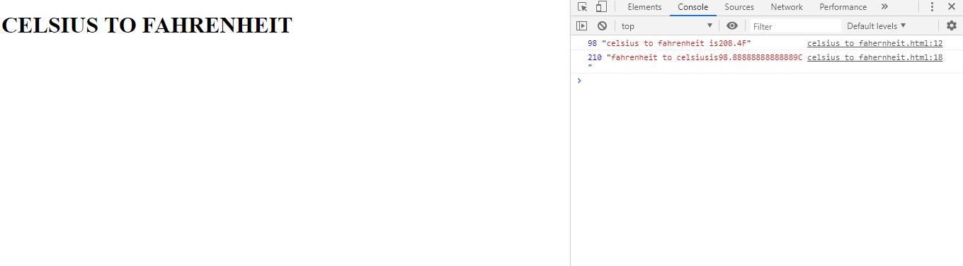

5: ELECTRICITY BILL

<!DOCTYPE html>

<html>

<head>

<title>ELECTRICITY BILL</title>

</head>

<body>

<h1>ELECTRICITY BILL</h1>

<script type="text/javascript">

function readingdetails(units)

{

if(units<=100)

{

res=units*2;

console.log("amount of eb bill " +res);

}

else if(units >100 && units<=200 )

{

unit1=units-100;

res=unit1*3+100*2;

console.log("amount of eb bill "+res);

}

else if(units>200)

{

res=(units-200)*4+100*2+200*3;

console.log("amount of eb bill "+res);

}

}

result=readingdetails(600);

</script>

</body>

</html>

**OUTPUT**:

